Completed Event Summary
Broome County Countywide Resiliency Plan
Community Workshop #2 - Broome County Regional Farmer’s Market

Event Details
Field | Information
Event Name | Broome County Countywide Resiliency Plan Community Workshop #2 – Broome County Farmer’s Market Tabling Event
Event Date | 6 June 2026
Event Time | 9:00 a.m. to 1:00 p.m.
Event Location | 840 Front St, Binghamton, New York
Host / Organizer | Countywide Resiliency Plan (CRP) engagement led by Broome County Department of Planning and Economic Development and J. Nucci Consulting.
Audience / Participants | General public and community partners attending the Farmer’s Market. The event was marketed via social media graphic posted on County channels.
Estimated Attendance | ~ 25 - 30 individuals visited the table at the Farmer’s Market
Number of Responses / Comments Collected | The Farmer's Market outreach centered on gathering adverse impacts that people experienced, encouraging residents to fill out the survey, and requesting residents to share the survey with their networks. Attendees were encouraged to add stickers to the engagement boards to indicate locations with climate impact. The project team recorded public comments during conversation.
Event Materials Used | CRP Project Information board; Countywide map for hazard identification; Close-up map of Disadvantaged Communities; Colored hazard dots; flyer; QR code/project webpage referral; Coloring pages.

Event Description
The purpose of Community Input Session #2 was to introduce the Broome County Countywide Resiliency Plan (CRP) to the public and gather public input on local climate-related hazards and issues that can inform the vulnerability assessment, community needs identification, strategy development, and project development.
The event was held as a pop-up tabling engagement during the Broome County Regional Farmer’s Market. Attendees visited the table, which was located near the coffee vendor, so residents happily talked with the project team while they waited in line for coffee. The overall format was informal and interactive. Discussions focused on local climate issues such as flooding and stormwater, severe storms, water runoff, impermeable surfaces, and the need for education and responsible development in the floodplain and areas which are subject to flash flooding.
Many attendees talked about the severe storm of July 3rd, 2025, that occurred proximally to the venue. Several green dots (signifying severe storm and infrastructure damage) were added to the map from the July 3rd event. Residents reported significant hail damage, wind damage, and tree loss during this storm which was a localized event. Although no tornado was confirmed, residents reported that the damage was consistent with tornadoes. One attendee estimated an impacted area of about 4 square miles.

Key Activities of the Event
The table below summarizes the major engagement activities.
Activity | Engagement Type | Purpose
Project Information Center / Pop-Up Booth | Pop-up engagement; informal public information table identified by flyers for pick-up and a Project board describing the CRP process. | Introduce the CRP, explain the planning process, invite public participation, and direct residents to additional input tools.
Interactive Hazard Mapping | Mapping activity; dot placement; place-based hazard identification | Collect location-specific information on where participants experienced or observed natural hazards.
Staff-Facilitated Informal Conversations | Informal discussion; facilitator notes | Gather more detailed context from visitors through one-on-one or casual conversations.
Project Website / Survey / Online Input Tool Promotion | Referral to website and online engagement tools; QR code outreach | Extend participation beyond the in-person event and direct residents to the project webpage, community survey, and interactive mapper.

Key Learnings from Discussion
- First responders are often neighbors helping neighbors. This was discussed in the context of the severe storm/wind event on July 3, 2025. This storm was localized and occurred near the Farmer’s Market.
- Solar development needs to be done responsibly. There was discussion of a proposed solar installation where there would be clearing of a hill with trees in a location that already suffered from flooding. A few people talked about this project and how green energy must be more thoughtfully addressed considering broader community needs, such as flood resilience. There was community action in Chenango to stop this development effort. Attendees who discussed this event were not against solar power, but rather against irresponsible placement/ development in their community.
- There needs to be more public education on flood response. Topics in need of public education included evacuation routes, warning systems, and preventative measures such as backwater valves, sump pumps, backflow preventers, and back-up generators.
- Mitigating development in the floodplains. Attendees reported adverse impacts of floodplain development to the people nearby. Attendees shared that placing low-income housing in the floodplain is irresponsible and adversely impacts vulnerable populations.

Activity Descriptions

Interactive Mapping Activity for Natural Hazards
Participants placed colored dots on physical maps to show where they had experienced or observed natural hazard events. Maps included a countywide view and a close-up of Disadvantaged Communities. Flood-related dots were the most visible mapped input. Other categories, including heat, winter storm, severe storm/infrastructure damage, property flood, and other hazards, also were also identified contributions from this activity. The project team will digitize the final map dots and compare them with floodplains, stormwater infrastructure, DAC/PEJA/CJEST areas, critical facilities, and prior hazard data before using the map results for project prioritization. The image of the map included in this summary is the sum of input from Earth Fest and the Farmer’s Market. Most attendees were from Binghamton, so the engagement with the close-up map is significantly higher than with the county-wide map.

Facilitated Booth Conversations / Intercept Discussions
Project team members documented informal conversations with visitors to the CRP table. Attendees shared a wide range of ideas which are recorded in the table below.

Project Website / Survey / Online Input Tool Promotion
During the event the project team promoted the CRP project webpage, survey, and interactive mapper through the flyer and QR code. This activity was intended to extend participation beyond the in-person event and provide an opportunity for residents who did not provide input at the booth to participate later.

Facilitator Notes
The table below records conversations between the project team and residents during the tabling event.
Location | Discussion | Notes
City of Binghamton | A resident was evacuated from Lourdes Hospital to Wilson Medical Center during administration of Pitocin to induce labor. Another pregnant and full-term resident was stranded in their home after the 7/3/25 storm downed trees. Their baby was born on 7/4/25 when she could get to a hospital. The storm caused $65k of damage to her property.
Binghamton Southside | Flooding on Mill Street used to be a problem.
Town of Binghamton | Lydia Street flooded in 1932, 2006, and 2011
First Ward Binghamton | Evacuation orders came at midnight with no direction of where to go. Then the First Ward was directed to go to the airport, but nothing was set-up.
Proposed solar installation in Chenango off Smith Hill Rd. | Developers wanted to clear cut a hill for solar in an area where there is already flooding issues. Clear-cutting the hill would have exacerbated the flooding. This is evidence of poor planning, and the development was cancelled due to public outcry. After 2 years of public pressure, developers pulled the project. There is need for municipal education so local governments know of the risks of development and the burden does not lay on the shoulders of residents who would be adversely affected, to protect themselves and their property. | Julie followed up and sent the meeting in a box and community flyer.
Chenango | Location: Knapp Hill Road; After the 2006 flood, cement slabs were added by the creek. A resident reported lost 2' of creek in 2006 and debris raised the height of the creek. In 2011 the creek wasn't breached, but a downed tree caused flooding nearby. | Suspected waterbody is an outlet at convergence of Knapp Rd, Parsons Rd, and MIX Rd; Slabs were placed to slow velocity of runoff, and to stabilize creek bed and bank.
West Chenango | One family got tired of losing power so they put in a solar PV system with batteries for storage. In summer they send more power to the grid than they use.
Banta Road, Conklin | Access to homes was cut off during 7/3/25 storm.
Conklin | Residents had trouble evacuating during the 2011 flood. A resident spoke about how neighbors helped neighbors evacuate. The resident used a boat to evacuate others. The water was shoulder deep. They had no power for almost a week. Dead cattle and propane tanks were floating down the river. They had not received any evacuation orders, did not know the evacuation route, and did not know about a notification system. Community education on disaster response was a priority for this resident. Their storage unit in Jonhson City flooded as well. This resident wanted to promote riparian buffers along the waterways for stabilization.
Hawleyton Road | A basement flooding from a strong storm took out the power and the sump pump. The resident did not have a generator. Education, sump pumps, and generators are a priority for residents.
Maines Food and Party Warehouse | A resident explained how they created an impromptu storm shelter at Maine and brought people to safety during the 7/3/2025 severe weather event. It is another example of the importance of citizen action to keep people safe.
Nanticoke Creek | Nanticoke Creek was up 19' in 2006, up 23' in 2011. The water was at the top of the dike/ levee. With another 6" of water, all of W. Endicott would have flooded.
Patterson Creek - Endwell | There has been so much development. There is more flooding from increased impermeable surfaces. The attendee happened to have a backwater valve (upon the recommendation of their plumber) so they did not get sewage backing up into their basement. Most of their neighbors did not have a backwater valve. Education about backwater valves and backflow preventers would be helpful.
Town of Union | An attendee expressed the Town of Union made decisions which caused sewer back-ups in Endwell.
Town of Union | An attendee talked about how the Industrial Development Agency (IDA) made a lot of development in the floodplain and put in a lot of houses. They said the IDA was not forthcoming with information about this development. Their loved ones live on Watson Blvd., and the property is devaluing from flooding. This resident’s property never flooded until the newer floodwall was built, so while it helped some people, it seems to have hurt others. Unlike the solar installation, this one was not stopped by public action. The resident blamed this on a lack of local oversight and lack of consideration of local opinions. They emphasized stronger local code for responsible development in the floodplain. Putting low income housing in the floodplain is antithetical to protecting vulnerable populations.
All | More efforts are needed for how to evacuate the less mobile and more dependent residents during evacuations.
All | Look for gray zones (over-use of building energy and under-production by PV systems); Need proper regulations for solar installations; Have more parks along the river so people can engage with them and have ownership for taking care of them. | Julie notes this is consistent with local college professor Jamie Vanucci’s work.
All | The project team discussed with a New Visions Government teacher about her using the meeting in a box with her students and giving us feedback. Julie asked her to forward the materials to component school districts. | Julie followed up and sent the meeting in a box and community flyer.

Overall Event Learnings and Insights to Inform the CRP
- Flooding remains both a countywide and highly localized concern. Participants described riverine, creek, stormwater, basement, and sewer-related flooding in and around Binghamton, Chenango, Conklin, Endwell, the Town of Union, and other locations. The comments show that risk is experienced not only during major river floods, but also through neighborhood drainage constraints, access interruptions, creek conditions, and infrastructure interaction.
- The July 3, 2025 severe storms illustrate cascading impacts beyond mapped flood hazards. Reported hail, wind, downed trees, property damage, power loss, blocked roads, disrupted access to medical care, and the need for an improvised shelter demonstrate how a localized event can quickly become a public-safety, mobility, health, and continuity-of-services issue. The CRP should consider severe storms and tree-related access and power disruptions as a top concern when evaluating vulnerabilities.
- Preparedness, communication, and evacuation support are recurring needs. Residents reported late, unclear, or absent evacuation information; uncertainty about routes, shelters, notification systems, and concern about evacuating people with limited mobility or greater dependence on assistance. At the same time, examples of neighbors using boats, informal shelters, and other resident-led responses show that community networks are an important resilience asset that can be strengthened through planning, training, and clearer communication.
- Participants linked resilience to land-use decisions, infrastructure, and household-scale measures. Comments connected added impervious surfaces, floodplain development, hillside clearing, sewer backups, and changes associated with flood-control infrastructure to increased or redistributed risk. Suggested measures included stronger local oversight, riparian buffers, riverfront parks, backup power, sump pumps, generators, backwater valves, and solar storage. These ideas point to a mix of policy, capital, nature-based, and education strategies for the CRP to evaluate.
- The results of this event will be interpreted as qualitative input. The comments and mapped dots will not be treated as a measure of prevalence but rather used to identify lived experiences, validate or challenge existing data, flag locations for follow-up, and shape additional outreach and analysis.

Next Steps
- Incorporate feedback from the mapping activity into the vulnerability assessment as community input. This involves translating the in-person mapping activity to the online digital mapper and using the data to support the vulnerability assessment.
- Report back to participants and the public. Post the event summary on the county website with information on how residents can continue participating through the survey, mapper, future events, or Meeting-in-a-Box activities.
- Evaluate strategies for evacuation communication, accessible transportation and sheltering, backup power, road and tree-clearance needs, basement and sewer-backup protection, drainage, riparian stabilization, and responsible floodplain and solar development.
- Conduct targeted follow-up with municipalities and service providers. Use the location-specific comments to confirm conditions and identify feasible interventions with municipal departments, emergency-response partners, utilities, healthcare and social-service providers, and community organizations. Clarify where education or updated procedures can address gaps alongside capital projects.
- Follow up with attendees and organization with whom meeting-in-box materials were shared. Incorporate kit feedback into engagement summary and vulnerability analysis.

Event Photos
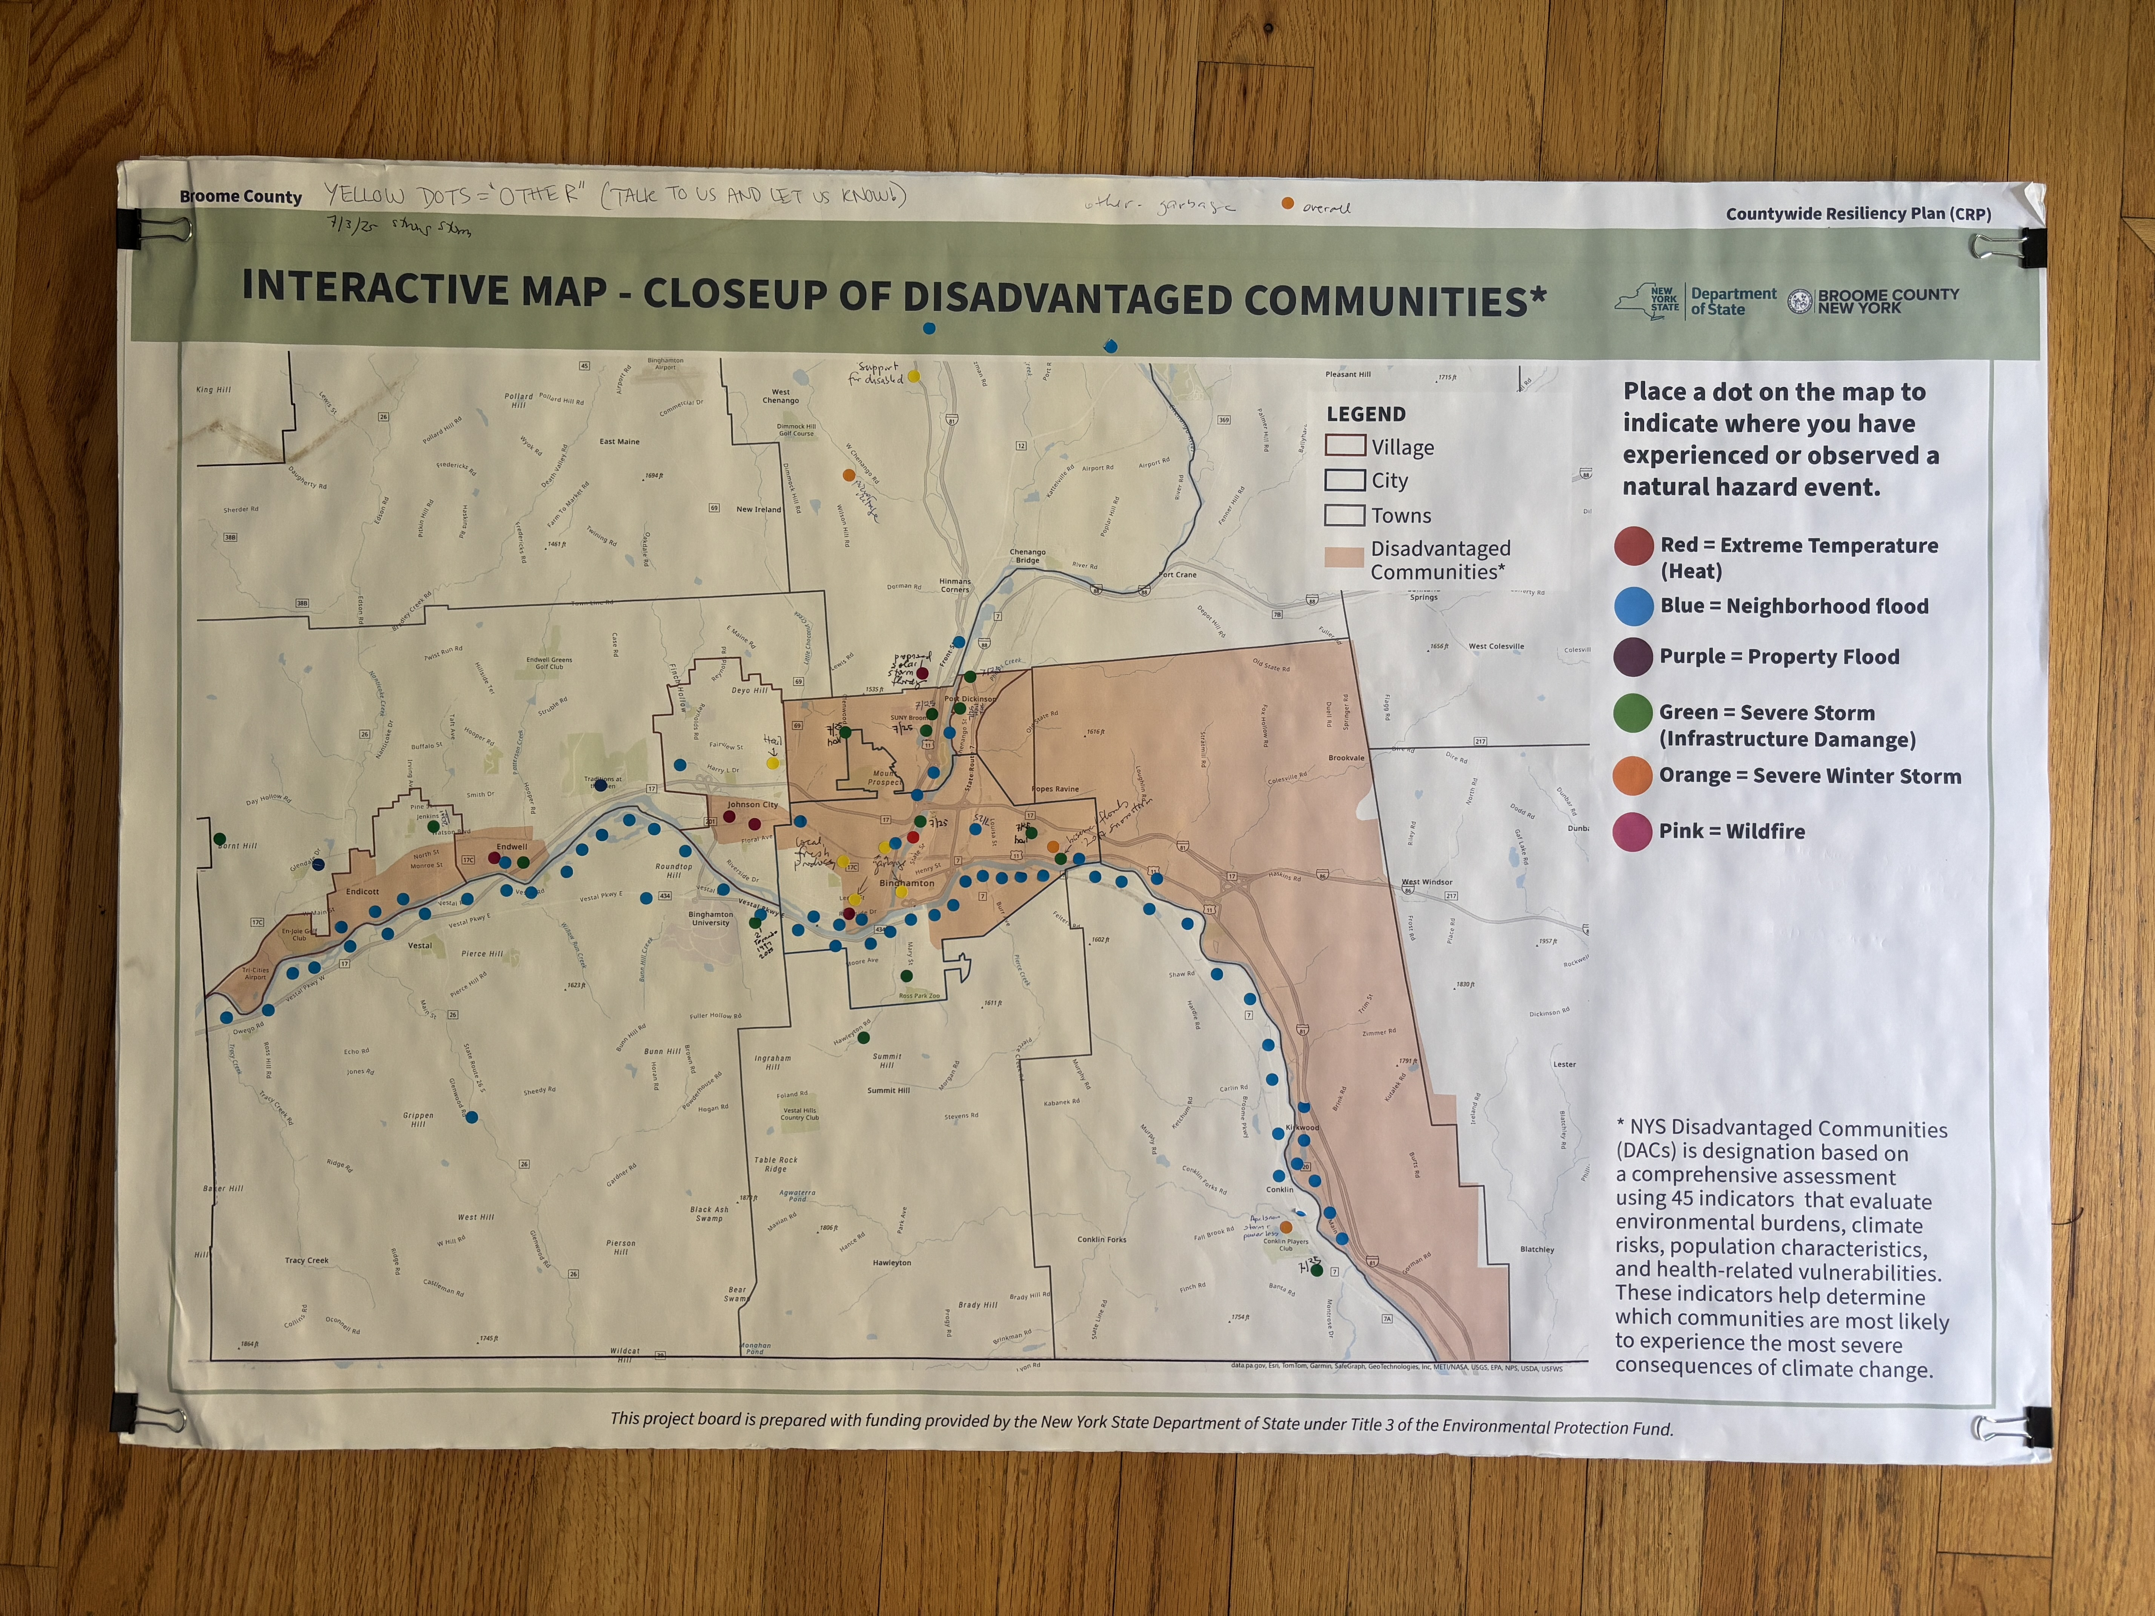
Interactive Map Board with input from attendees – Earth Fest/ Farmers Market
End of event summary.

