Completed Event Summary
Broome County Countywide Resiliency Plan
County-led Community Outreach #2 – CCE EcoFest
August 16, 2026 | 11:00 a.m. to 3:00 p.m. | Cornell Cooperative Extension of Broome County

Event Details
Field | Information
Event Name | Cornell Cooperative Extension (CCE) EcoFest, Broome County
Event Date | August 16, 2026
Event Time | 11:00 am-3:00pm
Event Location | Cornell Cooperative Extension of Broome County, Binghamton, New York
Host / Organizer | Countywide Resiliency Plan (CRP) engagement led by Broome County Department of Planning and Economic Development
Audience / Participants | General public.
Estimated Attendance | ~ 30 individuals visited the booth
Number of Responses / Comments Collected | Comments collected were recorded in facilitator notes
Event Materials Used | CRP Project Information board; Countywide map for hazard identification; Close-up map of Disadvantaged Communities; Sticky notes; flyer; QR code/project webpage referral.

Event Description
On August 16, 2026, Broome County Department of Planning and Economic Development staffed a community engagement table at the Cornell Cooperative Extentions’s EcoFest. The table included interactive maps and project overview materials. Conversations with EcoFest attendees focused on experiences with flooding, power outages, transportation and evacuation, communication, infrastructure reliability, housing, and neighborhood-level preparedness. Participants also identified specific locations where past storms or recurring conditions have created difficulties. Comments were captured through direct conversation and handwritten notes.
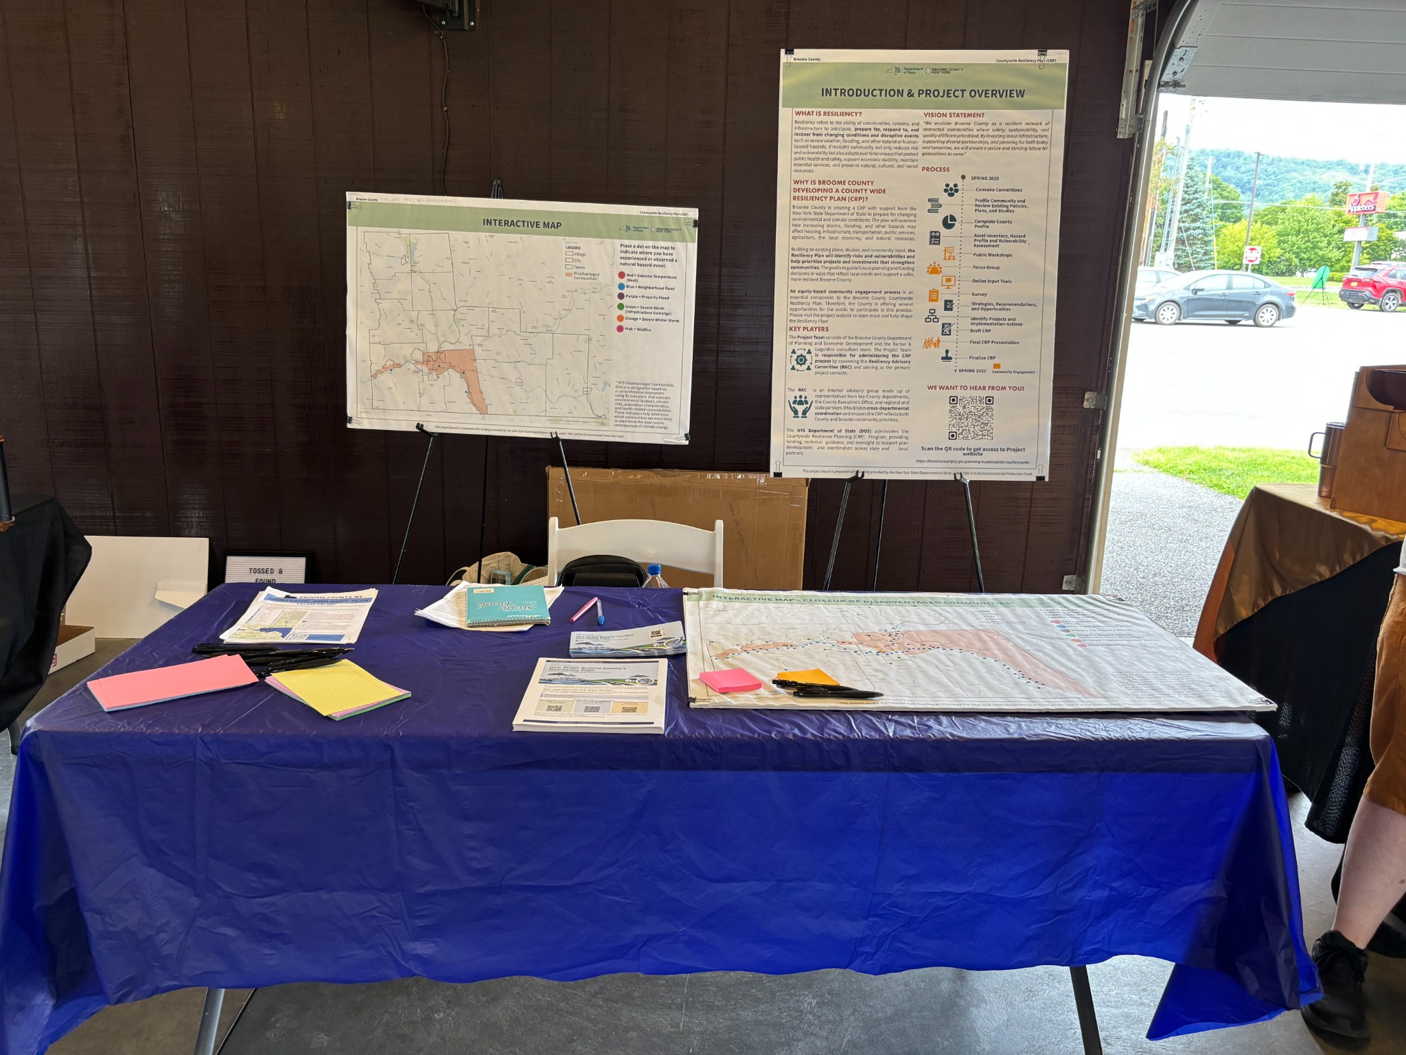 | 
Figure 1. Community Resiliency Plan outreach table with interactive mapping and project information. | Figure 2. CCE EcoFest venue showing the broader community event and exhibitor setting.

Facilitator Notes

Afton / Northeastern County
Residents near Afton / I-88 county boundary felt the northeastern part of the county receives less attention. Mail carriers have had to add roughly 10 miles to routes because of disruptions/closures. After the 2011 flood, commuting to Johnson City was difficult; knowing back roads was important. It was commented that Sanford should keep public spaces mowed.

Housing and recurring flooding
The need for more low-income housing was expressed. Residents avoid underpasses in Endicott because they flood frequently. Emma Street underpass near PM Press in Endicott “always floods.”

Transportation, evacuation, and basic needs
There was an expressed need for better communication about alternate routes and evacuation, especially for residents without cars. 164 Riverside Dr was evacuated – 12 people at this address, multiple persons with disabilities. Carlton Street was evacuated; Residents had difficulty obtaining food and medicine. Community members with barbecue grills helped feed people. Big Zeus on State Street as a community kitchen / hunger outreach effort was also mentioned.

Utilities, communications, and continuity
Castle Creek post office: permanent closure was said to be happening. NYSEG affordability is concern; A complaint to the Public Service Commission was mentioned. Link employee stated that the facility reportedly never closed during the flood and was noted as an important legacy industry in Broome County. Cell service (AT&T) was described as poor in an area near Chenango Forks school and Airport Road. Gregg’s Marketplace/ Big M reportedly has filed insurance claims and experienced power outages in Whitney Point, often for more than a day; This person was noted as a useful follow-up contact.

Roads, slopes, drainage, and neighborhood flooding
I-88 between/near Exits 2–3 experienced landslide after a major storm. Sunrise Terrace reported trickle of water in a basement and spotty neighborhood flooding from natural springs. Onondaga Shores: clearing for a barn/workshop was associated with flooding; Participant shared that the area had not historically seen flooding and that clearing for development had changed conditions. It was shared to check runoff culverts before storm events.

2011 flood / flood-protection infrastructure
Water treatment facility was overwhelmed by flooding; pumps were brought in and where water was pumped were themselves inundated. End of Jackson Street drain was described as not functional. Water reportedly reached the top of a floodwall at the end of Telegraph St. A floodwall/levee segment was described as too short and breached. Washington Street floodwall was noted.

Event Learnings and Insights to Inform the CRP
Residents described interconnected challenges involving access, mobility, utility reliability, communication, social support, and the ability of households and local institutions to function during and after storms. The table below summarizes these findings into five key topic areas.

Key Findings | What was heard
Recurring local flooding remains highly visible | Underpasses, drainage points, natural springs, and neighborhood runoff were repeatedly cited, including Endicott locations, Sunrise Terrace, Onondaga Shores, and the I-88 corridor.
Access and evacuation are equity issues | Road closures and flooded underpasses can isolate residents, while households without vehicles, people with disabilities, and those needing food or medicine may face greater difficulty during evacuation.
Communication and redundancy matter | Participants emphasized alternate-route information, back-road knowledge, cell-service gaps, power outages, and the need for clear emergency communication.
Critical and community facilities need continuity | Comments referenced the water treatment system, post office service, employers, floodwalls, drains, and informal food support as important pieces of community functioning.
Maintenance and land-use decisions influence risk | Culvert checks, drainage maintenance, mowing/public-space upkeep, development clearing, and slope instability were all connected to perceived resilience.

Next Steps
- Map and validate recurring problem locations: Carry the named underpasses, drainage/floodwall concerns, I-88 slope issue, and neighborhood flooding areas into the plan’s hazard/asset mapping and confirm details with municipal and infrastructure partners.
- Transportation and evacuation recommendations: Address alternate routes, road-closure communication, transportation for people without vehicles, accessible evacuation, and continuity of access to food, medicine, and essential services.
- Elevate communications and utility resilience: Reflect cell-service gaps and extended power outages in emergency communications, backup-power, redundancy, and outreach strategies.
- Include maintenance and infrastructure readiness actions: Consider pre-storm culvert/drain checks, floodwall/levee condition review, drainage maintenance, and operational readiness of water/wastewater and other critical facilities.

End of event summary.

