BROOME COUNTY
DEPARTMENT OF AUDIT AND CONTROL

ACCOUNTS PAYABLE DOCUMENTATION AUDIT

FIRST QUARTER 2017

Alex J. McLaughlin, Comptroller
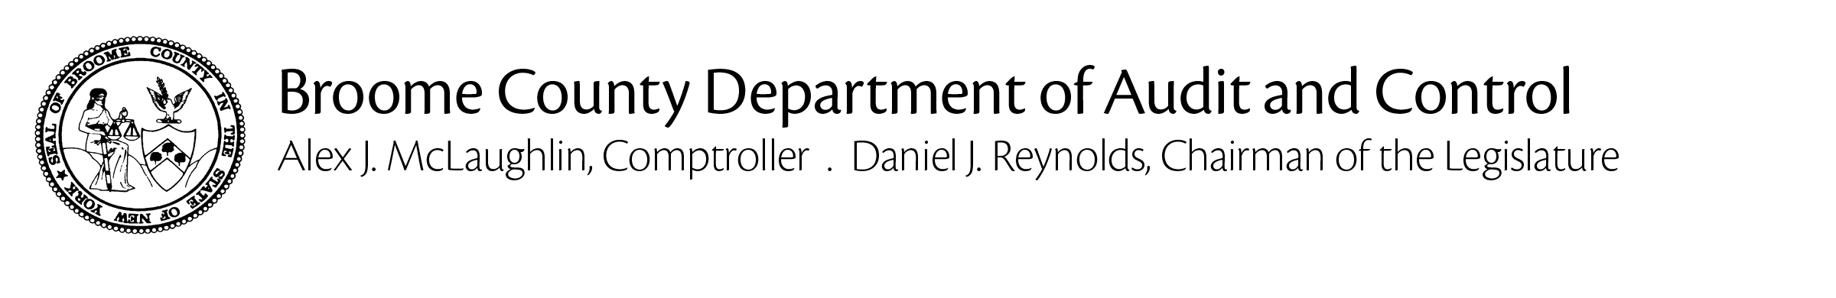
July 25, 2017

Jason T. Garnar, County Executive

The Department of Audit and Control has performed an audit of Accounts Payable documentation for the first quarter of 2017. The principal objective was to verify that amounts disbursed through the accounts payable process were proper in accordance with all applicable laws, regulations and policies and that they are supported by adequate, competent documentation.

The audit was conducted in accordance with generally accepted auditing standards. Such standards require that the Department of Audit and Control plan and perform the audit to adequately assess the accuracy of the financial records and adequacy of the internal controls and that we examine, on a test basis, sufficient, competent and relevant evidence to afford a reasonable basis for our conclusions.

Based on the results of our examination, it is our opinion that, except for the instance described herein, amounts disbursed through the accounts payable process were proper in accordance with all applicable laws, regulations and policies and that they are supported by adequate, competent documentation.

Sincerely,

Alex J. McLaughlin
Comptroller

Cc: Daniel J. Reynolds, Chairman of the Legislature
Members of the Legislature
Aaron M. Martin, Clerk of the Legislature
Kevin M. McManus, Deputy County Executive
Department Heads, Fiscal Contacts
BACKGROUND

Weekly, Broome County processes more than 1,000 vouchers, cuts nearly 500 checks and disburses nearly $7 million through its accounts payable system.

The Department of Audit and Control is responsible for auditing all of these disbursements to ensure that they are an appropriate use of County funds, that they are proper in accordance with all applicable laws, regulations and policies and that they are supported by adequate, competent documentation.

We use a two-step process to fulfill our auditing obligations with regard to accounts payable. First, we examine an electronic version of every payment request to ensure that it is appropriate, properly classified and made in accordance with applicable laws, regulations and policies. If these criteria are satisfied, the disbursement is approved. Then, we select a sample from these disbursements for detail testing. We visit each department and verify that the backup maintained to support the selected disbursements is adequate, correct and complete.

Any instances of non-compliance that we identified are included in this report.

REPORTABLE CONDITIONS

- PARKS

The Parks Department paid a contractor’s bill that did not include required supporting documentation for materials in the amount of $295. The applicable contract stipulates that any materials used by the contractor and billed to the County are to be supported by an invoice. In the case examined, the contractor used materials from its own inventory and billed the County for them, simply listing them on an attached sheet. We understand that it probably makes sense for the contractor to maintain an inventory of commonly used items and to bill them to clients as used, but that is not what the contract requires. The contract should either be amended or complied with.

