DEPARTMENT OF
AUDIT AND CONTROL

CASH VERIFICATION AUDITS

May 2017

Alex J. McLaughlin, Comptroller
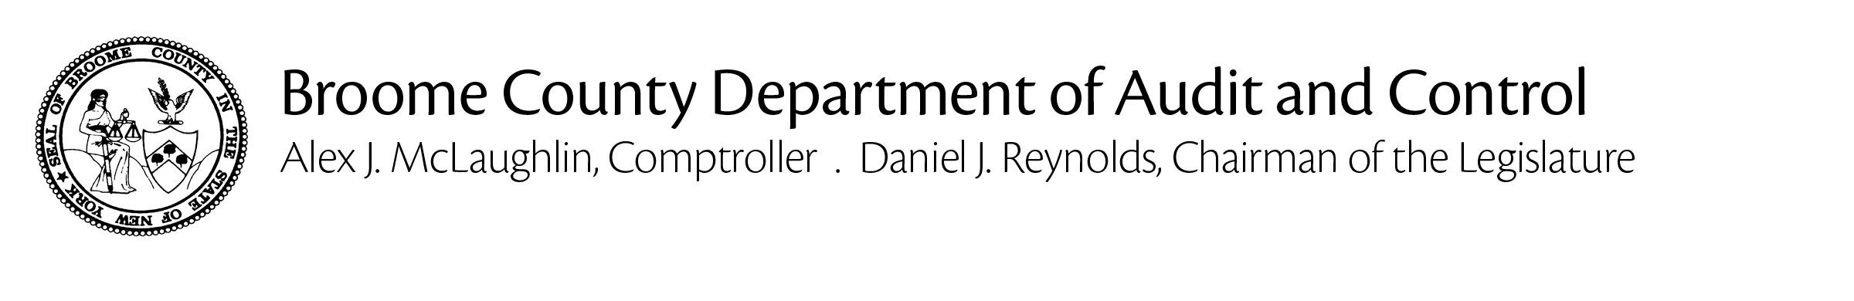
May 31, 2017

Jason T. Garnar, County Executive:

The Department of Audit and Control has completed Cash Verification Audits for the petty cash funds of several County departments. The examination of the petty cash funds was made in accordance with generally accepted auditing standards. The principle objective was to determine if the departments were accounting for their petty cash in accordance with the policy established in the Broome County Administrative Code, A216.

Based on the results for our examination, except for the instances noted herein, it is our opinion that the departments are following the appropriate policies and procedures to monitor and record petty cash transactions.

Sincerely,

Alex J. McLaughlin
Comptroller

cc: Daniel J. Reynolds, Chairman of the Legislature
Members of the Legislature
Aaron M. Martin, Clerk of the Legislature
Kevin M. McManus, Deputy County Executive
Jerome Z. Knebel, Director, OMB
Jennifer L. Yonkoski, Director, BMTS
Robert Behnke, County Attorney
Thomas Dellapenna, Risk Manager
Thomas Behan, Personnel Officer
Dennis O’Keefe, Director, Information Technology

BROOME COUNTY PETTY CASH FUNDS

AUDIT DATE | CASH FUND | FUND AUTHORIZED | AUDITED AMOUNT | NOTE | OVER (SHORT)
3/9/2017 | BMTS | $ 200.00 | $ 200.00 | D | $ (2.28)
3/9/2017 | Law | $ 250.00 | $ 250.00 |  | $ -
3/9/2017 | Risk and Insurance | $ 100.00 | $ 100.00 |  | $ -
3/21/2017 | Real Property | $ 2,500.00 | $ 2500.00 | D | $ (5.58)
3/21/2017 | Personnel | $ 50.00 | $ 50.00 |  | $ -
3/24/2017 | Information Technology | $ 200.00 | $ 200.00 |  | $ -
3/28/2017 | Planning | $ 400.00 | $ 400.00 |  | $ -

BROOME COUNTY PETTY CASH FUNDS

TABLE OF NOTES

(A) | VALIDATED LETTER WAS NOT IN PLACE  An authorized letter was not available and/or maintained with the department to document the fund amount and the appointed employee responsible for the petty cash fund. This letter must contain the signature of the department head that witnesses the assignment and the signature of the employee who accepts custody of the funds. This statement should be maintained by the department head or their representative and be available to auditors upon their audit of the fund.
(B) | VALIDATED LETTER FOR CURRENT CUSTODIAN WAS NOT IN PLACE  An authorized letter documenting the current appointed employee responsible for the petty cash fund. This letter must contain the signature of the employee who accepts custody of the funds. If there is a change in the custodian of said funds, then a new validated letter must be in place.
(C) | REMIT OVERAGE TO THE OFFICE OF MANAGEMENT AND BUDGET
(D) | VARIANCE NOTED IN PETTY CASH FUND  A petty cash replenishment should be processed, charging cash over/short for the shortfall.

