DEPARTMENT OF
AUDIT AND CONTROL

COMMISSARY ADMINISTRATION AUDIT

Sheriff’s Office
December 2018

Alex J. McLaughlin, Comptroller
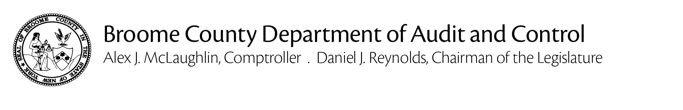

December 6, 2018

Sheriff David E. Harder,

The Department of Audit and Control has conducted an audit of the Sheriff’s Office Inmate Commissary Fund. The principle objective was to ascertain whether commissary funds are being used and accounted for properly in accordance with State Corrections Law.

The audit was conducted in accordance with generally accepted auditing standards. Such standards require that the Department of Audit and Control plan and perform the audit to adequately assess the accuracy of the financial records and adequacy of the internal controls, and that we examine, on a test basis, sufficient competent and relevant evidence to afford a reasonable basis for our conclusions. The scope of our audit was limited to insuring that Commissary Fund monies are being used and accounted for properly.

Based on the results of our examination, it is our opinion that the Sheriff’s Office is in compliance with State Law regarding the commissary fund.

Sincerely,

Alex J. McLaughlin
Comptroller

Background Information:

The Commissary is designed for the purpose of making available, for sale to prisoners, personal and convenience items deemed appropriate by the Sheriff or Chief Administrative Officer, consistent with the health and welfare of the prisoners and the security and general operation of the facility. The commissary fund consists of the profit the Sheriff’s Office makes when inmates buy items (hygiene items, candy, chips, snacks and other miscellaneous items such as writing pads, stamps, pencils, cards, envelopes, etc.).

Profits from commissary sales are deposited in a separate bank account and are utilized only for purposes of prisoner welfare and rehabilitation. State Law requires that profits from the jail commissary to be used to purchase items to benefit inmates. At the end of October 2018, the balance in the commissary fund was $175,036.96. The commissary funds are not part of the budget.

The primary objective of this audit was to insure that statutory requirements related to the administration of the commissary are being complied with.

Prior Audit

November 2017

AUDIT FINDINGS, RECOMMENDATIONS AND RESPONSES

- No Findings -

